H.T No
Regulations:
A14

Sreenidhi Institute of Science and Technology
(An Autonomous Institution)
Code No: 4B202 Date: 21-Aug-2023 (FN)

B.Tech I-Year II- Semester External Examination, Aug/Sept-2023 (Supplementary)
Engineering Drawing – II (Common to All)

Time: 3 Hours Max.Marks:70
Note: a) No additional answer sheets will be provided.
b) All sub-parts of a question must be answered at one place only, otherwise it will not be valued.
c) Missing data can be assumed suitably.

Bloom's Cognitive Levels of Learning (BCLL)

Remember | L1 | Apply | L3 | Evaluate | L5
Understand | L2 | Analyze | L4 | Create | L6

Part - A Max.Marks:20

Answer all QUESTIONS.

 |  | BCLL | CO(s) | Marks
1 | What are the applications of the scales of chords? | L2 | CO1 | [2M]
2 | Name and explain the methods used for obtaining the development of pyramids and cones with one example? | L3 | CO2 | [2M]
3 | What are isometric planes? | L2 | CO3 | [2M]
4 | Discuss the applications of Isometric projections. | L3 | CO4 | [2M]
5 | What is a station. What is its relation with the visible rays? | L2 | CO5 | [2M]
6 | Name five edit commands used in CAD. | L1 | CO6 | [2M]
7 | Differentiate between plain scale and diagonal scale? | L3 | CO1 | [2M]
8 | Differentiate between isometric projection and orthographic projections? | L3 | CO3 | [2M]
9 | Define the following terms with respect to perspective projections.  (i) ground Plane (ii) picture plane (iii) horizontal plane | L1 | CO5 | [2M]
10 | What are the information necessary for a scale? | L2 | CO1 | [2M]

Part – B Max.Marks:50
ANSWER ANY FIVE QUESTIONS. EACH QUESTION CARRIES 10 MARKS.

 |  |  | BCLL | CO(s) | Marks
11. |  | A train is running at a speed of 40 km per hour. Construct a comparative scale to read a kilometer and a minute and long enough to read up to 50 km. The R.F. of the scale is 1:250000. On the scale show the distance travelled by the train in 42 minutes. | L5 | CO1 | [10M]
12. |  | A hexagonal hole of side 25 mm is cut in a cylindrical drum of diameter 50 mm and height 70 mm. One of the faces of the hole is perpendicular to HP and the axis intersects with that of the drum at right angles. Draw the development of its lateral surface. | L4 | CO2 | [10M]
13. |  | Draw the isometric view of the given orthographic projections (in first angle) shown in Fig. (All dimensions are in mm)  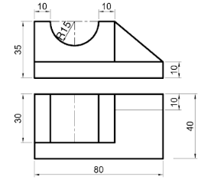 | L4 | CO3 | [10M]
14. |  | Draw front view, top view and side view for the below fig. (All dimensions are in mm)  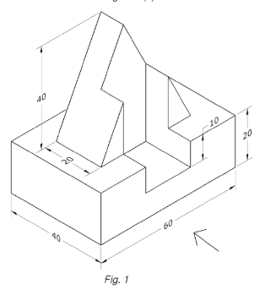 | L3 | CO4 | [10M]
15. |  | A hexagonal pyramid of base side 30 mm and axis 65 mm rests on the ground plane with an edge of the base parallel to and 10 mm behind the picture plane. The station point is 40 mm above the ground and 70 mm in front of PP and 50 mm towards the right of the axis of the pyramid. Draw its perspective projection. | L4 | CO5 | [10M]
16. |  | What is a CAD. State the advantages of CAD? Write the prompt sequence for drawing a rectangle of 50 mm x 35 mm with the help of a line command. | L2 | CO6 | [10M]
17. |  | A composite solid is made up of a rectangular block of 75mm and 40mm side and 30mm height, and semi-cylinders of diameter 75mm and height 30mm attached on two opposite flat vertical faces of the block. Draw its isometric projection. | L4 | CO1 | [10M]
18. |  | Draw the Front view Top view and side view for the following figure.  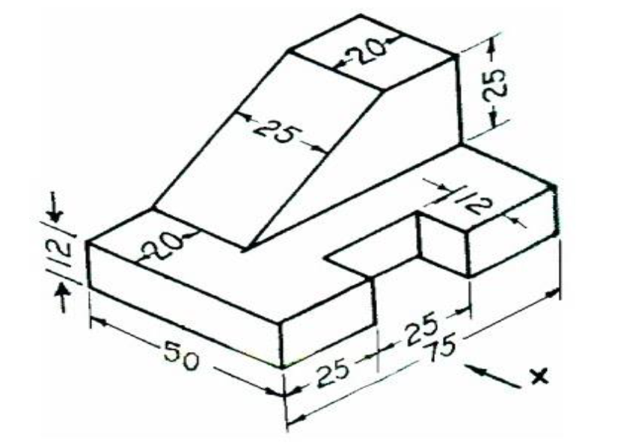 | L4 | CO4 | [10M]

-- 00 -- 00 –

